Use Case Diagram 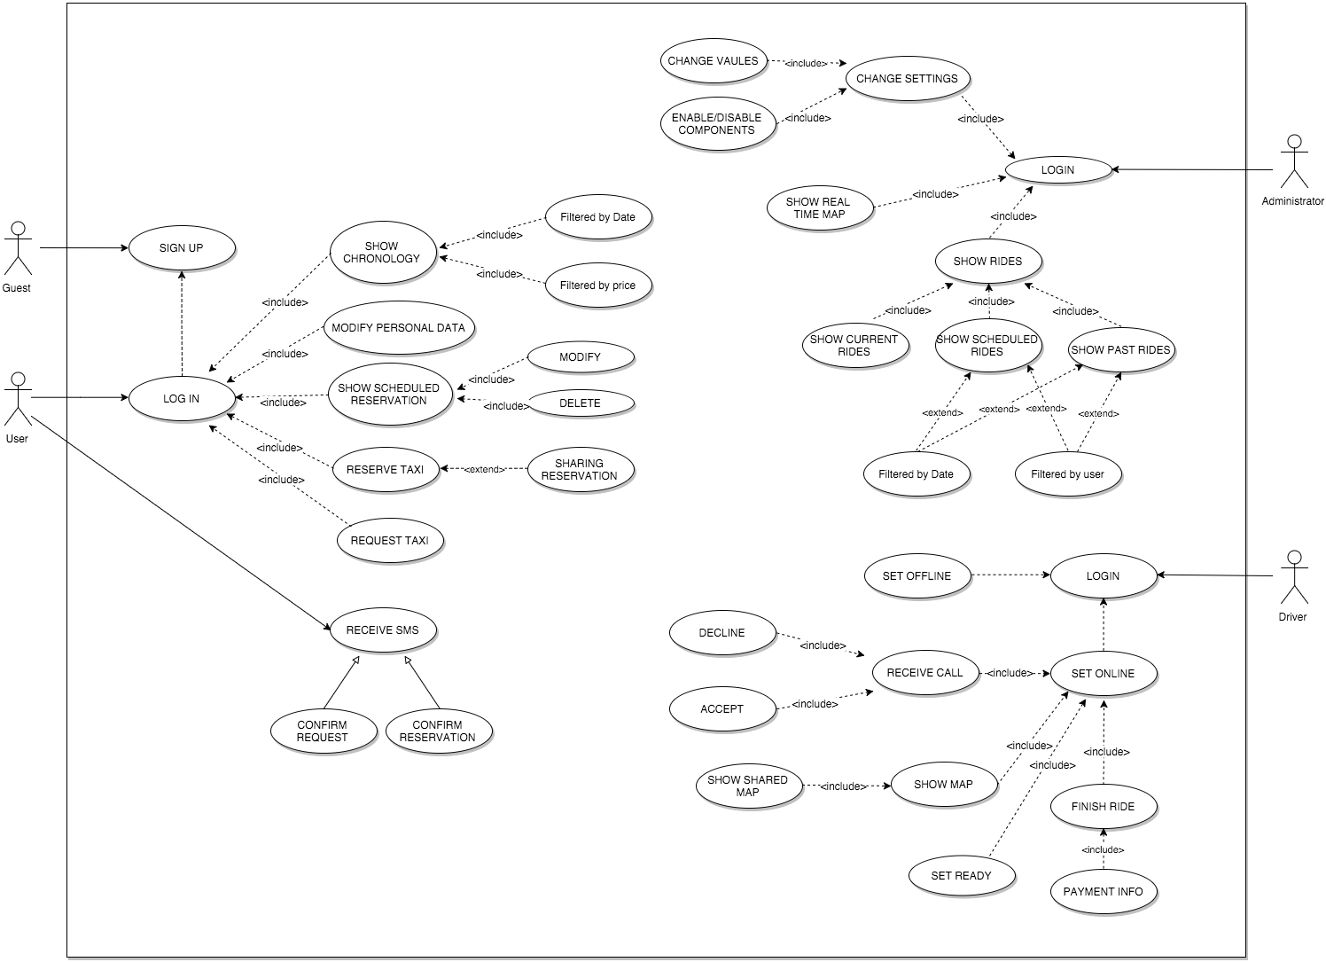

We can derive some use cases from the scenarios identified in the previous paragraph:

1. USER SIGN UP
2. USER LOG IN
3. RESERVE TAXI
4. RESERVE WITH SHARING
5. REQUEST TAXI
6. SHOW SCHEDULED RESERVATION
7. SHOW CHRONOLOGY
8. DRIVER LOGIN
9. RECEIVE CALL
10. SHOW MAP
11. SET READY
12. ADMIN LOGIN
13. CHANGE SETTINGS
14. SHOW RIDES
15. MANAGE DRIVERS

|  |  |
| --- | --- |
| Name | Sign Up |
| Actors | Guests |
| Entry Conditions | The Guest isn’t registered into the system |
| Flow Events | * The guest access to MTS via mobile app or web app * If he have a Facebook account he can signup via Facebook, in this case after the authorization he has to insert the phone number and than he has access to the homepage. * If he want to register without Facebook he has to compile the form with the following info: - First Name - Last Name - Phone number - Email address - Birthday * He clicks Sign Up bottom * The system show him a successful operation message and it send him an email with all data inserted, a password random generated by the system and the instruction about the first login. |
| Exit Conditions | Registration successfully done. |
| Exceptions | Guest is already registered (the email address is already in use). He doesn’t compile all fields of the registration form. He inserts a not valid birthday. He inserts a not valid mail address. |

|  |  |
| --- | --- |
| Name | Log in |
| Actors | User |
| Entry Conditions | The User is already registered. |
| Flow Events | * The user access to MTS via mobile app or web app * He clicks the login button * If he has registered via Facebook he tap the” login via Facebook button” * Otherwise he inserts email address and password * He clicks Login bottom |
| Exit Conditions | The system shows him the homepage |
| Exceptions | He inserts wrong username/password |

|  |  |
| --- | --- |
| Name | Reserve a Taxi (no sharing) |
| Actors | User |
| Entry Conditions | The user is already logged in and he is on the homepage |
| Flow Events | * User clicks “reserve taxi” button * He compiles the form with the following info: - Origin address - Origin house number - Destination address - Destination address number - Number of passengers - Date - Start time * He click done button |
| Exit Conditions | System accept the reservation. It shows him a confirmation screen and it sends him a SMS message about the confirm. |
| Exceptions | User insert a not valid address. User insert a not valid date/time (according to reservation time limits) |

|  |  |
| --- | --- |
| Name | Reserve a Taxi with sharing |
| Actors | User |
| Entry Conditions | The user is already logged in and he is on the homepage |
| Flow Events | * User clicks “reserve taxi” button * He compiles the form with the following info: - Origin address - Origin house number - Destination address - Destination address number - Number of passengers - Date - Start time * He switched on the sharing button * He click done button |
| Exit Conditions | System accept the reservation. It shows him a confirmation screen and it sends him a SMS message about the confirm. |
| Exceptions | User insert a not valid address. User insert a not valid date/time (according to reservation time limits) User insert a not valid number o passengers (according to specifications) |

|  |  |
| --- | --- |
| Name | Request a Taxi |
| Actors | User |
| Entry Conditions | The user is already logged in and he is on the homepage |
| Flow Events | * User clicks “request taxi” button * He compiles the form with the following info: - Origin address - Origin house number - Number of passengers * He click done button |
| Exit Conditions | System accept the request. It shows him a confirmation screen and it sends him a SMS message about the confirm. |
| Exceptions | User insert a not valid address. User insert a not valid number o passengers (according to specifications) |

|  |  |
| --- | --- |
| Name | Show scheduled reservation |
| Actors | User |
| Entry Conditions | The user is already logged in and he is on the homepage |
| Flow Events | * User clicks “Show scheduled reservation” button * If he has made reservation and if he is allowed according to specifications he can delete or modify it. * If he taps modify button he can modify the start time and date * If he taps delete button he deletes the scheduled ride. * Only reservation that respect the specification parameters can be modified/cancelled, the other are shown without any possibility to change them. |
| Exit Conditions | If user modify the star time/date then system re-scheduled the ride, else if he taps delete, than the system delete the scheduled ride. After the change/delete a SMS message is send to the user to confirm the action. |
| Exceptions | User insert a not valid time/date. |

|  |  |
| --- | --- |
| Name | Show Chronology |
| Actors | User |
| Entry Conditions | The user is already logged in and he is on the homepage |
| Flow Events | * User clicks on chronology button * He can see all the request and reservation he has made, filtering them by date or price paid. |
| Exit Conditions | None |
| Exceptions | None |

|  |  |
| --- | --- |
| Name | Driver Login |
| Actors | Driver |
| Entry Conditions | Driver switch on his on-board device |
| Flow Events | * Driver inserts his ID * He inserts the password * He taps login button |
| Exit Conditions | System shows him the online/offline page |
| Exceptions | Driver insert a not valid id. Driver insert a not valid password |

|  |  |
| --- | --- |
| Name | SET ONLINE/OFFLINE |
| Actors | Driver |
| Entry Conditions | The driver is already logged in. |
| Flow Events | * Driver tap the online button   OR   * Driver tap the offline button |
| Exit Conditions | After he presses the online button on the device appears waiting for a call screen. After he presses the offline button on the device appears the set online screen. |
| Exceptions | None. |

|  |  |
| --- | --- |
| Name | RECEIVE A CALL |
| Actors | Driver |
| Entry Conditions | The driver is already logged in and online. On the device appears the alert. |
| Flow Events | * Driver sees the alert * He tap the confirm/denied button |
| Exit Conditions | After he presses the confirm button on the device appears the map After he pressed the denied button on the device appears the waiting for a call screen |
| Exceptions | None. |

|  |  |
| --- | --- |
| Name | SHOW MAP |
| Actors | Driver |
| Entry Conditions | The driver has already accepted a call |
| Flow Events | * If the call is for a request so on the device appears the map with the route the drive has to follow. The destination is the starting point where take passenger. When he arrives and find the passenger he tap the Start button, he insert the destination street (that passenger has told him) and on the device appears the map with route to destination. When taxi arrives at destination, the driver tap the finish button and a alert with total time and price is shown. If he doesn’t find anyone at the origin street he taps the report button and the ride is cancelled. After that a new map is shown with the new waiting for a call destination that driver has to reach. * If the call is for a reservation, system already known the destination so on the screen appears both the origin and destination street. When taxi arrives at destination, the driver taps the finish button and a alert with total time and price is shown. * If the call is for a sharing reservation on the screen appears the map and the list of user. System shows the route to take all users, when a user is taken on board driver has to tap the start button, when a user arrives at his own destination, taxi has to tap finish button and an alert with the relative price appears. |
| Exit Conditions | After the payment of the user (after the last user in sharing case) the system shows a new map with the new waiting for a call destination that driver has to reach. |
| Exceptions | None. |

|  |  |
| --- | --- |
| Name | SET READY |
| Actors | Driver |
| Entry Conditions | The driver has already logged in and he has just finished a ride. On the screen appears the alert with price and time of the course. |
| Flow Events | * Driver tap done button * On the screen appears a map with a new destination and the route about where he has to go. * When driver arrives at destination he tap the ready button |
| Exit Conditions | After the press of ready button the waiting for a call screen appears. |
| Exceptions | None. |

|  |  |
| --- | --- |
| Name | Administrator Login |
| Actors | Administrator |
| Entry Conditions | Administrator opens the MTS Admin page |
| Flow Events | * He insert id * He insert password * He clicks login button |
| Exit Conditions | System shows him the real-time map |
| Exceptions | Administrator insert a not valid id. Administrator insert a not valid password |

|  |  |
| --- | --- |
| Name | CHANGE SETTINGS |
| Actors | Administrator |
| Entry Conditions | Administrator has already made login |
| Flow Events | * Administrator clicks settings button * He changes one or more values among the ones available * He switch on/off the additional services buttons * He clicks on done button |
| Exit Conditions | System shows him the same page with new values. |
| Exceptions | none |

|  |  |
| --- | --- |
| Name | SHOW RIDES |
| Actors | Administrator |
| Entry Conditions | Administrator has already made login |
| Flow Events | * Administrator can visualize 3 kind of list: current rides, scheduled rides and past rides * If he clicks on current rides he sees a list of all current rides, with all info about driver, user (or users if share), origin and destination. * If he clicks on scheduled rides he can see the scheduled reservation with info of users, if it is sharing, starting time and the driver if it is already allocated. * If he clicks on past rides he can see all rides made by drivers with all info and price. |
| Exit Conditions | none |
| Exceptions | none |

|  |  |
| --- | --- |
| Name | MANAGE DRIVERS |
| Actors | Administrator |
| Entry Conditions | Administrator has already made login |
| Flow Events | * Administrator clicks on manage drivers button * System shows him the list of all drivers. * He can delete someone or he can add one driver * If he wants to add a new driver he has to click on add button, he compiles all fields of form (name, mobile phone number, number of license, and car plate. Then he clicks on add button and the system shows him a confirmation page with id number and password that administrator has to communicate to driver. * If he wants to remove someone he has to click the x button next to the selected name and system automatically removes it. |
| Exit Conditions | If there is a new driver: system shows the new id and password of the driver. If there is a removing, system delete driver and shows the new list without the selected driver. |
| Exceptions | Not all of the required fields are compiled. |